Guardians of the Mayan temples: microclimatic conditions of archaeological sites used as roosts by Chrotopterus auritus in Southeastern Mexico
Fernando Gual-Suárez*¹, Luis A. Trujillo^{1,2}, Javier Torres-Cervantes¹, Mayra Cristina Ordóñez-García¹, Rodrigo A. Medellín¹
¹Laboratorio de Ecología y Conservación de Vertebrados Terrestres, Instituto de Ecología, Universidad Nacional Autónoma de México, Circuito Exterior s/n, Ciudad Universitaria, C.P. 04510, Coyoacán, Ciudad de México, México. ²Posgrado en Ciencias Biológicas, Universidad Nacional Autónoma de México, Av. Ciudad Universitaria 3000, Ciudad Universitaria, C.P. 04510, Coyoacán, Ciudad de México, México.

Supplementary Material 1
Average internal temperature and relative humidity, external temperature, and difference between internal and external temperatures in three Mayan temple Chrotopterus auritus roosting sites. n indicates the number of data points (10 min intervals) obtained for internal temperature (in parenthesis, paired external temperature data points, variations due to device malfunction).
 | April |  | July |  | November-December |  | February
 | Night | Day | Night | Day | Night | Day | Night | Day
n (total T data points)
Hormiguero HL | 72 (0) | 127 (0) |  |  |  |  | 165 (216) | 216 (216)
Hormiguero HR | 622 (0) | 579 (0) | 216 (91) | 188 (105) | 216 (216) | 183 (133) | 936 (216) | 821(165)
Okolhuitz | 564 (0) | 508 (0) | 216 (216) | 184 (184) | 216 (216) | 207 (207) | 216 (216) | 216 (216)
El Corriental |  |  | 202 (86) | 204 (72) | 216 (216) | 162 (162) | 216 (216) | 209 (209)
Average Internal T (°C [min-max], SD)
Hormiguero HL | 26.1 [26.1-26.1], 2.1×10⁻²⁴ | 26.074 [26.1-26.1], 3.9×10⁻²⁴ |  |  |  |  | 22.8 [22.5-23.0], 0.2 | 22.8 [22.5-23.0], 0.2
Hormiguero HR | 25.6 [25.1-26.1], 0.4 | 25.6 [25.1-26.1], 0.4 | 27.2 [27.0-27.5],0.2 | 27.1 [27.0-27.5],0.1 | 24.5 [24.1-24.6], 0.1 | 24.5 [24.1-24.5], 0.2 | 23.1 [22.5-23.5], 0.2 | 23.1 [22.5-23.5], 0.2
Okolhuitz | 25.8 [23.1-28.1], 0.96 | 26.0 [22.6-28.1], 1.3 | 28.2 [27.6-29.6], 0.5 | 28.6 [27.6-30.6], 0.7 | 22.9 [22.1-24.1], 0.5 | 23.3 [22.1-24.1], 0.7 | 24.9 [24.1-25.6], 0.3 | 25.3 [24.1-26.1], 0.5
El Corriental |  |  | 26.4 [25.6-27.1], 0.4 | 26.5 [25.6-27.6], 0.5 | 19.8 [17.6-22.6], 1.3 | 20.4 [17.1-22.6], 1.6 | 22.4 [19.6-23.6], 1.0 | 22.7 [19.6-24], 1.1
Average External T (°C [min-max], SD)
Hormiguero HL |  |  |  |  |  |  | 23.8 [22.5-26], 0.8 | 26.5 [22.5-32.5], 2.7
Hormiguero HR |  |  | 27.4, [25.5-29.5], 1.1 | 28.8 [25.5-30.5], 1.7 | 24.2 [22.0-27.0], 1.4 | 28.1 [22.0-35.0], 3.2 | 23.8 [22.5-26], 0.8 | 26.5 [22.5-32.5], 2.7
Okolhuitz |  |  | 26.5 [24.5-30.5], 1.5 | 27.9 [24.5-32.5], 2.4 | 20.7 [19.5-22, 0.8 | 21.5 [19.5-22.5], 1.1 | 23.7 [22.5-26], 0.8 | 25.4 [22.5-28.0], 1.6
El Corriental |  |  | 26.2 [23.5-30.5],1.8 | 28.9 [23.5-35.5], 3.4 | 18.5 [16.0-21.0], 1.3 | 19.0 [16.0-21.5], 1.7 | 22.4 [19-24.5], 1.4 | 23.2 [18.5-25], 1.5
Average T difference (°C [min-max], SD)
Hormiguero HL |  |  |  |  |  |  | -0.2 [-3-0], 1.1 | -0.7 [-10-0], 4.2
Hormiguero HR |  |  | 0.0 [2.4-2.1], 1.3 | -1.6 [-3.4-2.1], 1.8 | 0.4 [-2.4-2.6], 1.3 | -3.6 [-10.4-2.6], 3.1 | -0.7 [-2.9-0.1], 0.7 | -3.4 [-9.4-0.6], 2.6
Okolhuitz |  |  | 1.8 [-0.9-3.1], 1.1 | 0.7 [-2.4-3.6], 1.8 | 2.2 [1.1-3.1], 0.4 | 1.8 [1.1-3.1], 0.5 | 1.2 [-0.9-1.6], 0.6 | -0.2 [-2.4-1.6], 1.1
El Corriental |  |  | 0.3 [-3.4-2.1], 1.4 | -2.2 [-8.4-2.1], 4.1 | 1.4 [1.1-1.6], 0.2 | 1.4 [0.6-2.1], 0.4 | 0.0 [-1.9-1.1], 0.6 | -0.5 [-1.9-1.1], 0.7
Average Internal RH (% [min-max], SD)
Hormiguero HL | 94.2 [92.4-96.3],0.91 | 94.0 [90.9-96.8], 1.3
Hormiguero HR | 78.3 [75.1-81.6], 1.4 | 78.3 [74.6-81.6], 1.6 | 90.2 [84.4-92.6], 1.4 | 89.3 [84.9-92.1], 1.6 | 86.5 [85.3-87.3], 0.5 | 86.3 [84.2-87.3], 0.5 | 86.1 [84.6-90.1], 0.7 | 86.4 [84.6-89.1], 0.8
Okolhuitz | 69.5 [41.9-77.8], 7.2 | 68.0 [40.6-78.9], 8.6 | 70.7 [60.2-74.9], 3.1 | 70.5 [58.4-78.2], 5.5 | 82.5 [80-84.8], 0.8 | 81.8 [76.2-86.3], 2.8 | 76.6 [68.5-82.1], 3.2 | 75.7 [65.6-84.1], 5.5
El Corriental |  |  | 74.9 [68.6-79.1], 2.5 | 76.4 [67.5-81.8], 3.0 | 87.3 [85.8-88.9], 0.6 | 86.8 [86.7-88.9], 0.8 | 85.6 [80.9-90.2], 2.3 | 84.8 [75.3-89.9], 3.5

Supplementary Material 2
Simultaneous daily variation in temperature and humidity data inside and outside the Hormiguero (HR and HL), Okolhuitz, and El Corriental roosts during April (A), July (B), and November-December (C) 2019 and February (D) 2020. A Hygrochron (DS1923) iButton (Maxim Integrated, USA) was used to collect temperature and humidity data inside the roosts. A Thermochron (DS1921G-F5) iButton (Maxim Integrated, USA) collected temperature data from outside the roost simultaneously. Data points were recorded every 10 minutes with a resolution of 0,5 °C and 0,6 %RH. Devices were placed on small rock ledges inside the chambers within 30 cm of the bats’ preferred roosting area in each temple to measure inner microclimatic conditions and on crevices near the entrance of each roost where they were exposed to outside air temperature but shielded from sunlight. At Hormiguero, the device was placed in whichever roost the bats were occupying upon our arrival at the site.
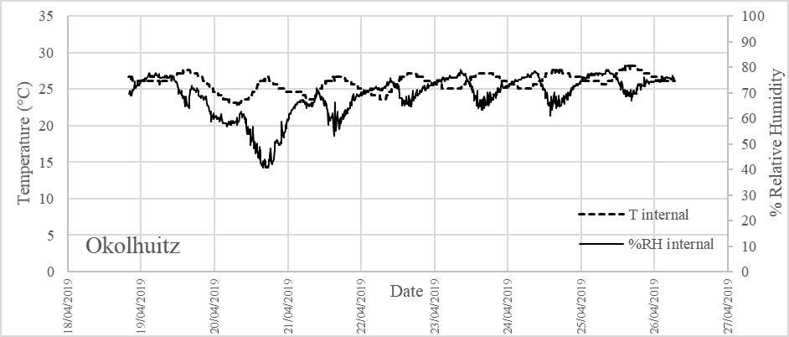
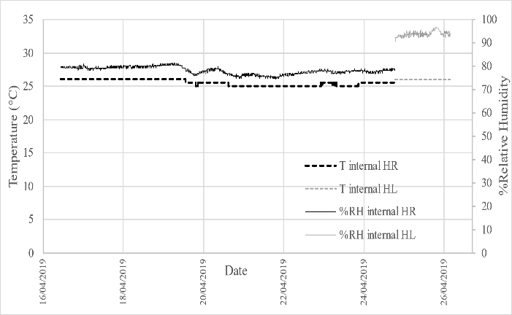
A
Hormiguero

B
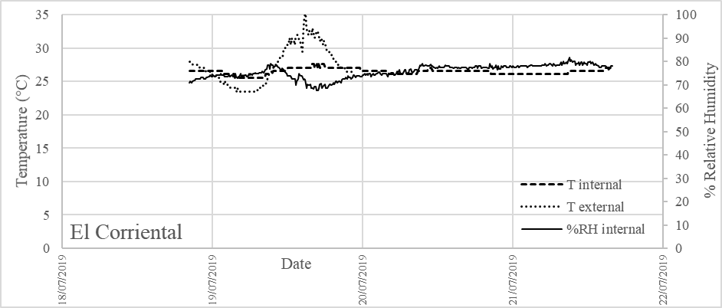
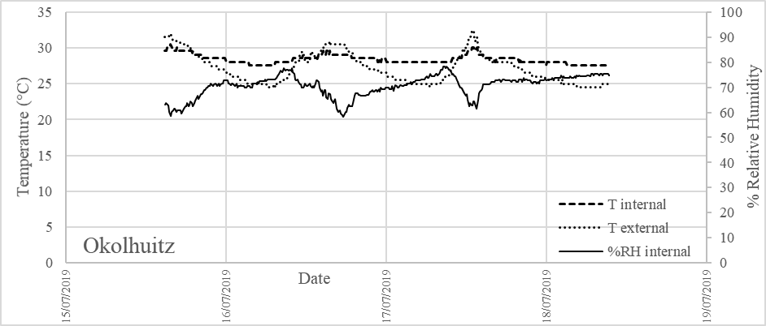
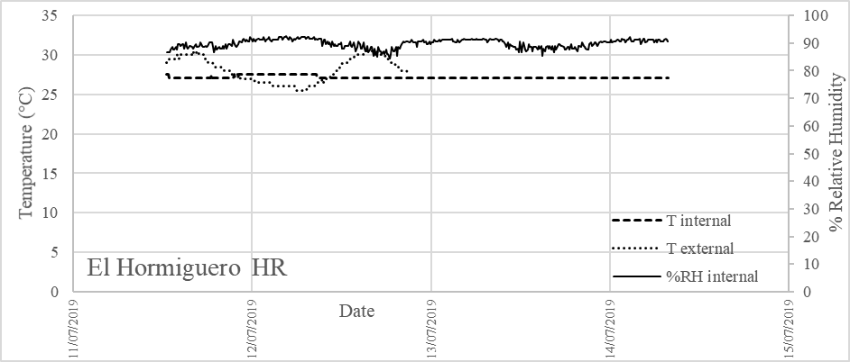

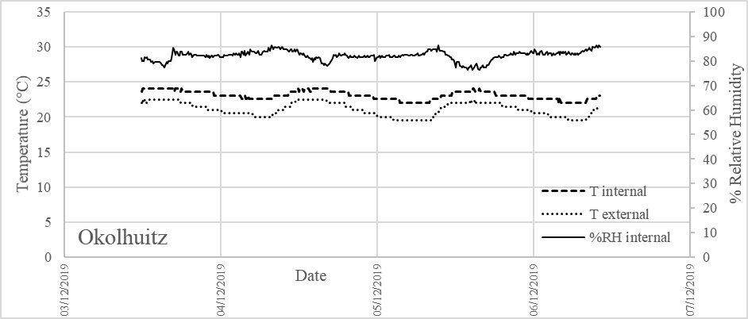
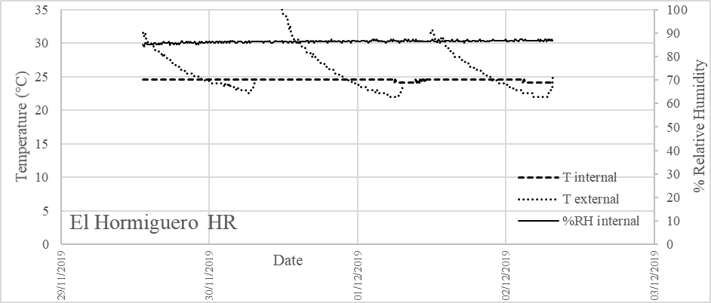
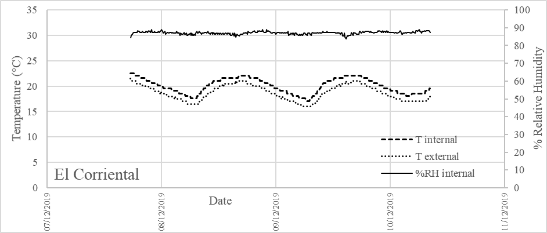
C

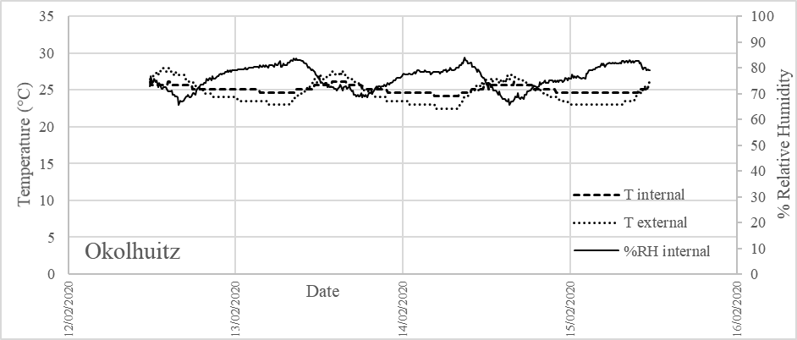
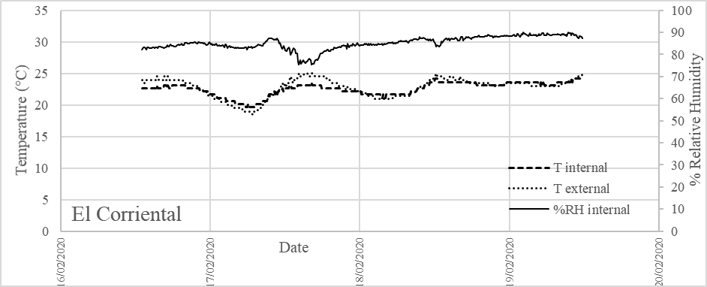
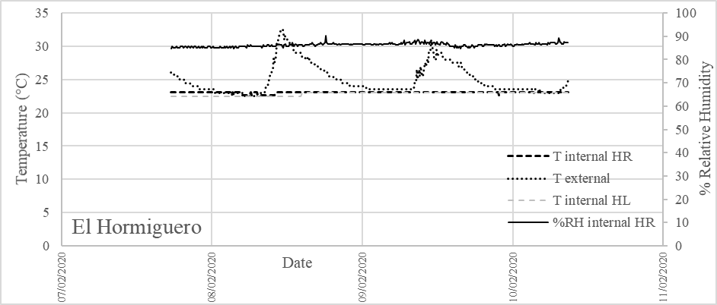
D

